Lab Report - Managing Files and Folders in Windows

# Aim

To learn how to create, delete, copy, move, rename, view, sort, zip, and unzip files and folders in Windows.

# Requirements

- A computer running Windows operating system

# Procedure / Steps

## 1. Creating Files and Folders

• Open File Explorer by clicking the folder icon on the taskbar or pressing Windows + E.

• Navigate to the desired location.

• Right-click in the folder, choose "New", and select file type (e.g., Text Document).

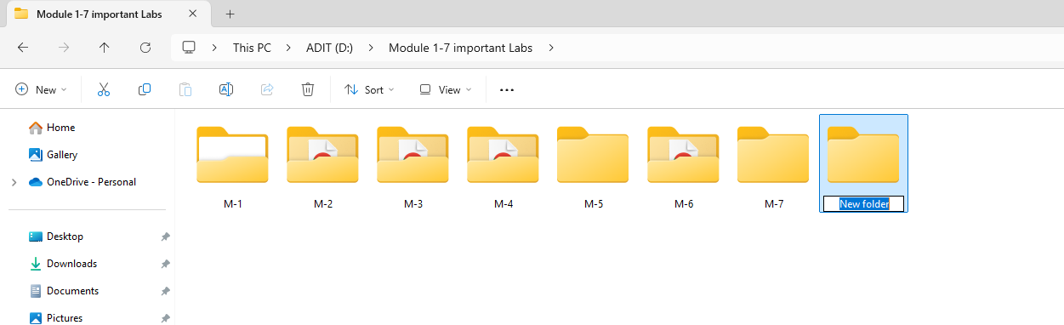

• Name the file and press Enter.

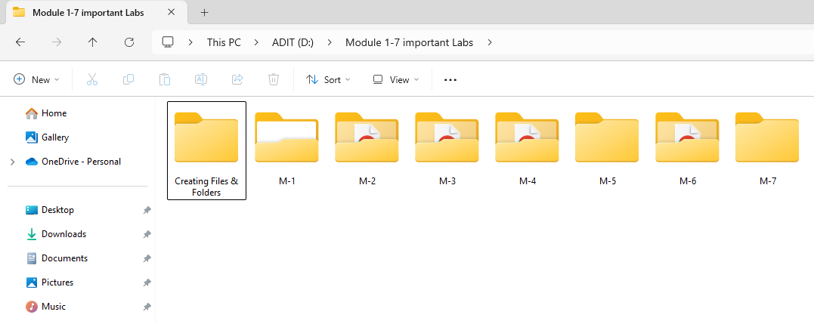

## 2. Deleting Files and Folders

• Open File Explorer and go to the file/folder location.

• Right-click and select "Delete" or press Delete key.

• Item is moved to Recycle Bin.

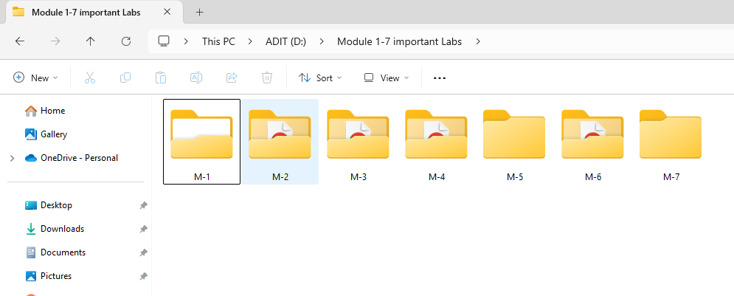

## 3. Copying and Moving Files and Folders

• Open File Explorer and locate the file to copy.

• Right-click and choose "Copy" or press Ctrl + C.

• Go to destination folder, right-click and select "Paste" or press Ctrl + V.

## 4. Renaming Files and Folders

• Open File Explorer and locate the file.

• Right-click and choose "Rename" or press F2.

• Enter new name and press Enter.

## 5. Viewing Files and Folders

• Open File Explorer and go to the folder.

• Click "View" tab or right-click and choose preferred view (Icons, List, Details).

## 6. Sorting Files and Folders

• Open File Explorer and go to the folder.

• Click "Sort" or right-click in the folder.

• Sort by Name, Type, Size, etc. in Ascending or Descending order.

## 7. Zipping Files and Folders

• Select files/folders to compress.

• Right-click and choose "Compressed (zipped) folder".

• Rename the zip file if needed.

## 8. Unzipping Files and Folders

• Locate the zip file in File Explorer.

• Right-click and select "Extract All".

# Conclusion

By following these steps, you can effectively manage files and folders in Windows, including creating, deleting, copying, moving, renaming, viewing, sorting, zipping, and unzipping.